**Project Flow:**

Based on the use case a new template with a page component has been created which has customized page properties.

**Application: /apps/BWI**

**Template: BWI Home Page Template**

**Execution process:**

Once the Bundle and Package got installed follow the below steps.

Step 1: Check if the service is registered in the bundle.



Step 1: Create a page using **BWI Home Page Template.**

Step 2: Configure launcher for the workflow.



Step 3: Add the page property to the page.

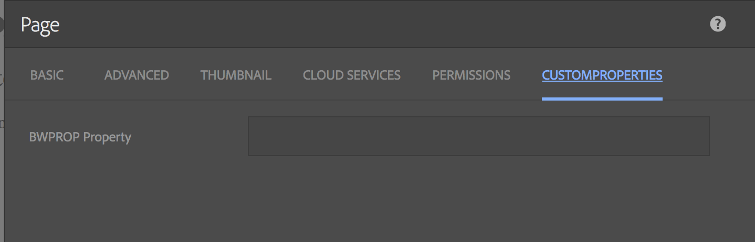

Step 4: Give the page property and check if the workflow is triggered.





Step 5: Check if the page is replicated to the publish instance.

By following all these steps, you should be able to replicate the page to publish instance by making sure the **BWPROP Property** is not empty.

